Reg. No:…………………………….
KIGALI INSTITUTE OF SCIENCE AND TECHNOLOGY
INSTITUT DES SCIENCES ET TECHNOLOGIE
Avenue de l'Armée, B.P. 3900 Kigali, Rwanda


INSTITUTE EXAMINATIONS – ACADEMIC YEAR 2013

END OF SEMESTER EXAMINATION: MAIN EXAM
FACULTY OF ENGINEERING
COMPUTER ENGINEERING & INFORMATION TECHNOLOGY

FIRST YEAR SEMESTER II
MAT 3131 APPLIED PROBABILITY AND STATISTICS
DATE: / /2012
TIME: 2 HOURS
MAXIMUM MARKS = 60
INSTRUCTIONS
- This question paper contains Two (2) parts: A and B.
- Part A has 10 questions each having 2marks, and Part B has 3 questions each with 20 marks.
- Answer all questions in part A, and choose any two in Part B.
- No written materials allowed.
- Do not forget to write your Registration Number.
- Do not write any answers on this question paper.
PART A (Short answer questions)
- When A and B are 2 mutually exclusive events such that P(A)=1/2 and P(B)=1/3, find P(A∪B).
- What is the difference between qualitative and quantitative variables with examples?
- If E and F are two independent events with P(E)=1/2 and P(F)=1/2, evaluate the P(E∪F).
- If X has uniform distribution in (-3, 3) find P(-2< x < 2)
- The mean of a binomial distribution are 2, for n =4, Find 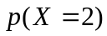
- The probability that a bit transmitted through a digital transmission channel is received in error is 0.1. Assume the transmissions are independent events, and let the random variable X denote the number of bits transmitted until the first error, calculate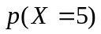.
- Suppose the current measurements in a strip of wire are assumed to follow a normal distribution with a mean of 10 milliamperes and a variance of 4 (milliamperes)2. What is the probability that a measurement will exceed 13 milliamperes?
- Assume that MTN randomly selects 2 phone numbers from a group of 20 to determine the SHARAMA winner. What are your odds of winning if you purchased one ticket?
- What is the power of a statistical test?
- Given that Z is the standard normal distribution evaluate 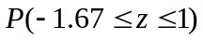

PART B
Question 1.
The following data give the worldwide number of fatal airline accidents of commercially scheduled air transports in the years from 1997 to 2005.
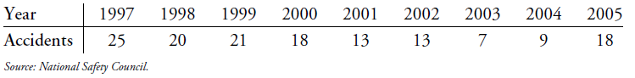
- Set up a relative frequency distribution of the number of accidents in these years [3marks]
- Construct a frequency histogram [3marks]
- Calculate the mean, median, mode, and range of the number of accidents in these years. [8marks]
- Determine the skewness of the data [2marks]
- Find variance and standard deviation of the number of accidents from 1997 to 2005 [4marks]
Question2
- A homeowner randomly samples 64 homes similar to her own and finds that the average selling price is $252,000 with a standard deviation of $15,000. Is this sufficient evidence to conclude that the average selling price is greater than $250,000? Use ⍺ = .01. [10marks]
- Tom and Dick are going to take a driver's test at the nearest DMV office. Tom estimates that his chances to pass the test are 70% and Dick estimates his as 80%. Tom and Dick take their tests independently. [10marks]
- What is the probability that at most one of the two friends will pass the test?
- What is the probability that at least one of the two friends will pass the test?
- Suppose we know that only one of the two friends passed the test. What is the probability that it was Dick?

Question 3.
- The weights of packages of ground beef are normally distributed with mean 1 pound and standard deviation 0.1.
- What is the probability that a randomly selected package weighs between 0.80 and 0.85 pounds? [5marks]
- What is the weight of a package such that only 5% of all packages exceed this weight? [5marks]

- The number of messages sent per hour over a computer network has the following distribution:
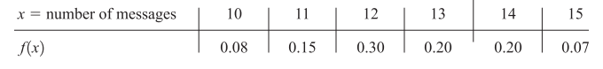
- Determine the mean and standard deviation of the number of messages sent per hour. [6marks]
- Calculate the probability of sending more than the average. [4marks]
Cumulative Probabilities Table for the Standard Normal Distribution
